ADMIN

1. First, you need to go to the homepage of CleckShopHub and then you can find LOGIN button at the navigation bar at top right.

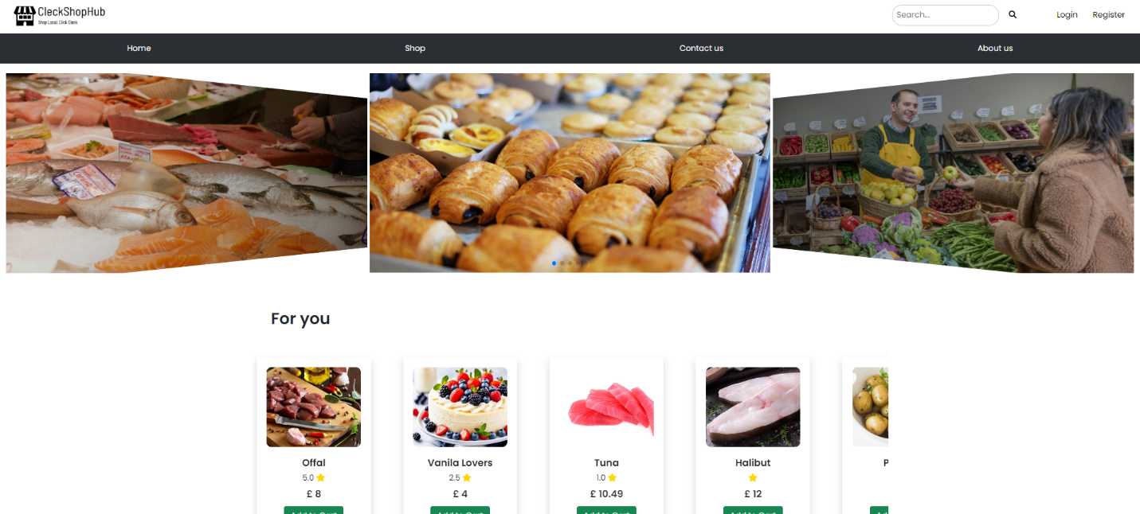

1. Once you are in the Login page, fill in the form with admin login credentials.

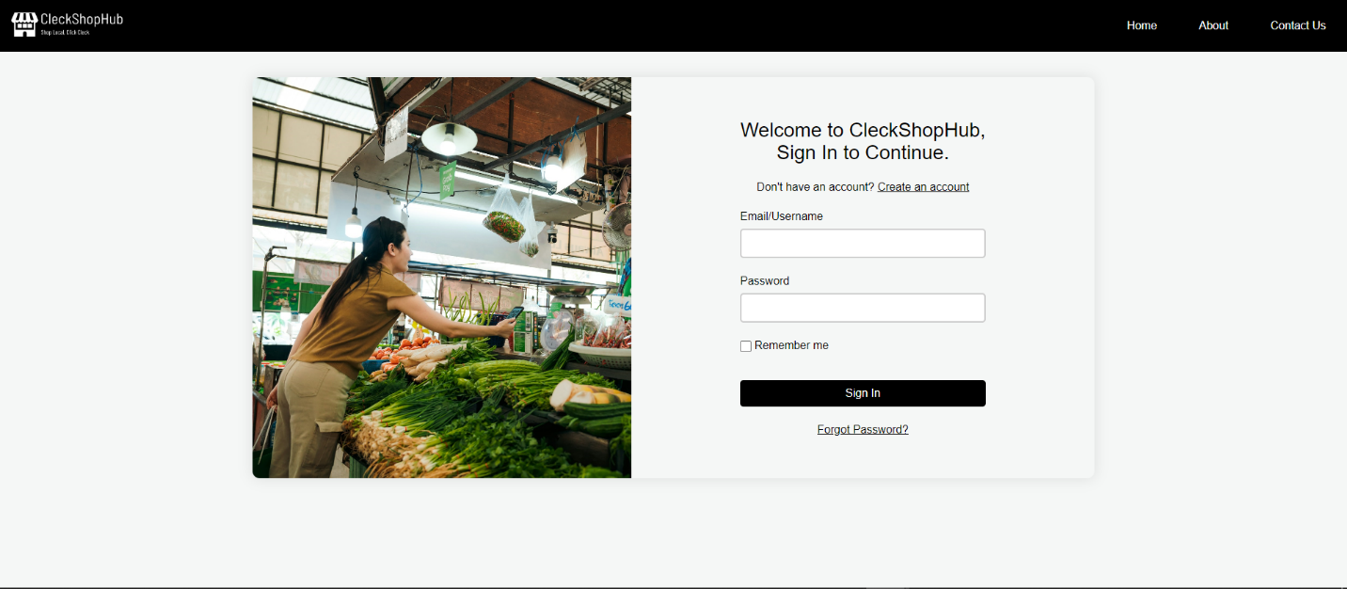

1. Once the correct admin login credentials are filled, you will be directed towards Dashboard. The dashboard will display information such as total number of users and customers, the messages from contact us form and the number of approved traders and pending traders.

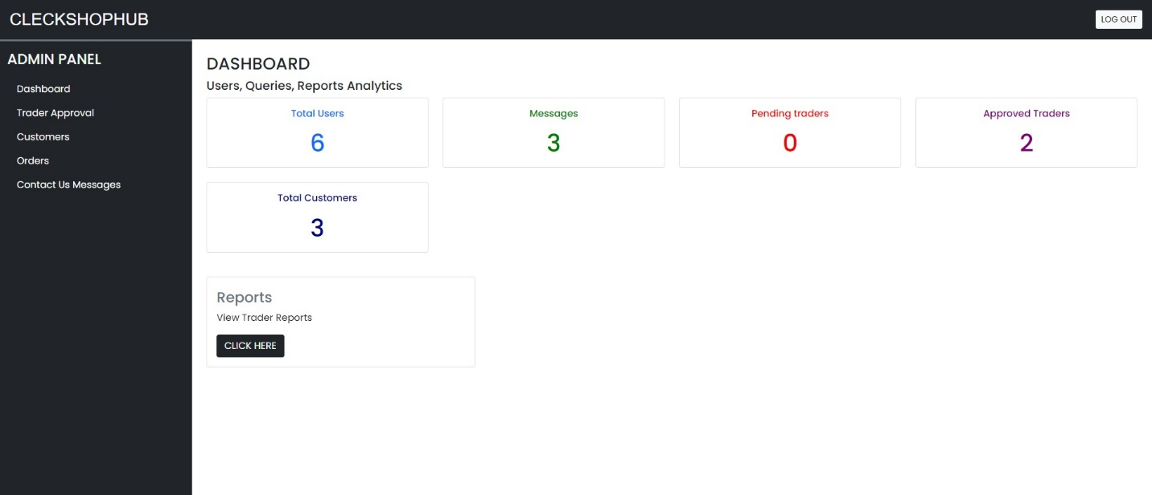

1. You can see all the approvals by clicking on the Trader approval tab on the left side. You can disapprove any current traders by clicking on the red ‘disapprove’ button and to approve traders, the admin can press on the green ‘approve’ button.

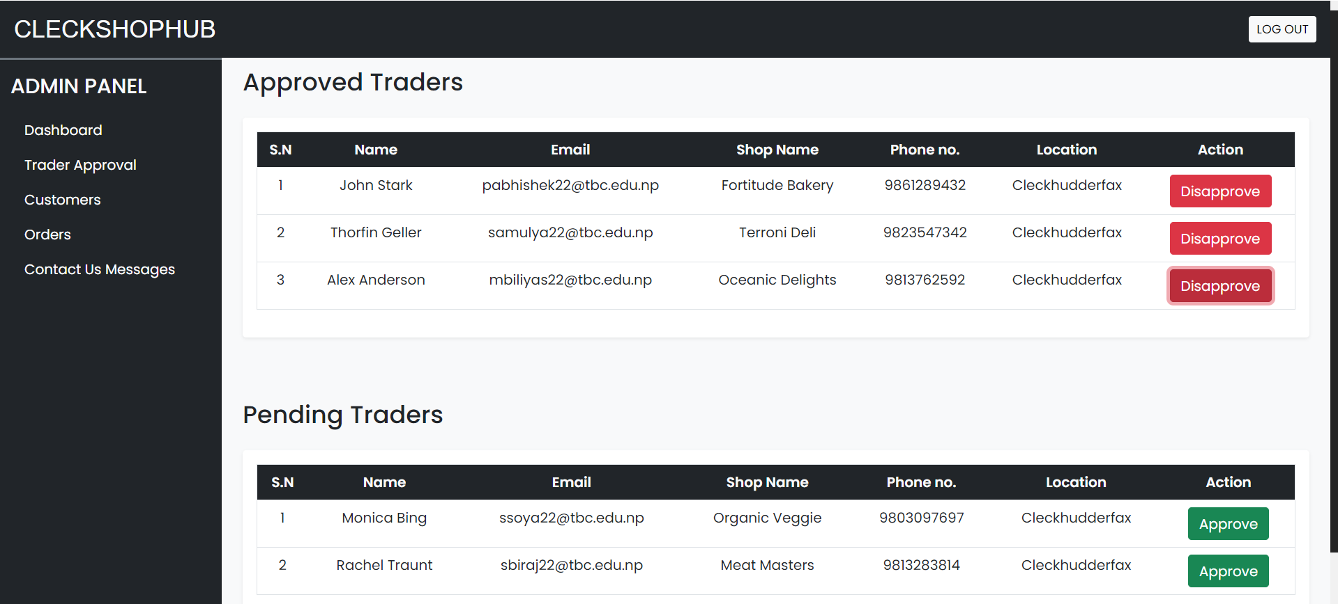

1. You can view all the registered customers after clicking on the Customer tab on the left side.

The customers are displayed with their username and email along with phone number and their roles. ‘C’ denotes a customer. Admin can also remove the customer by clicking on the red delete button.

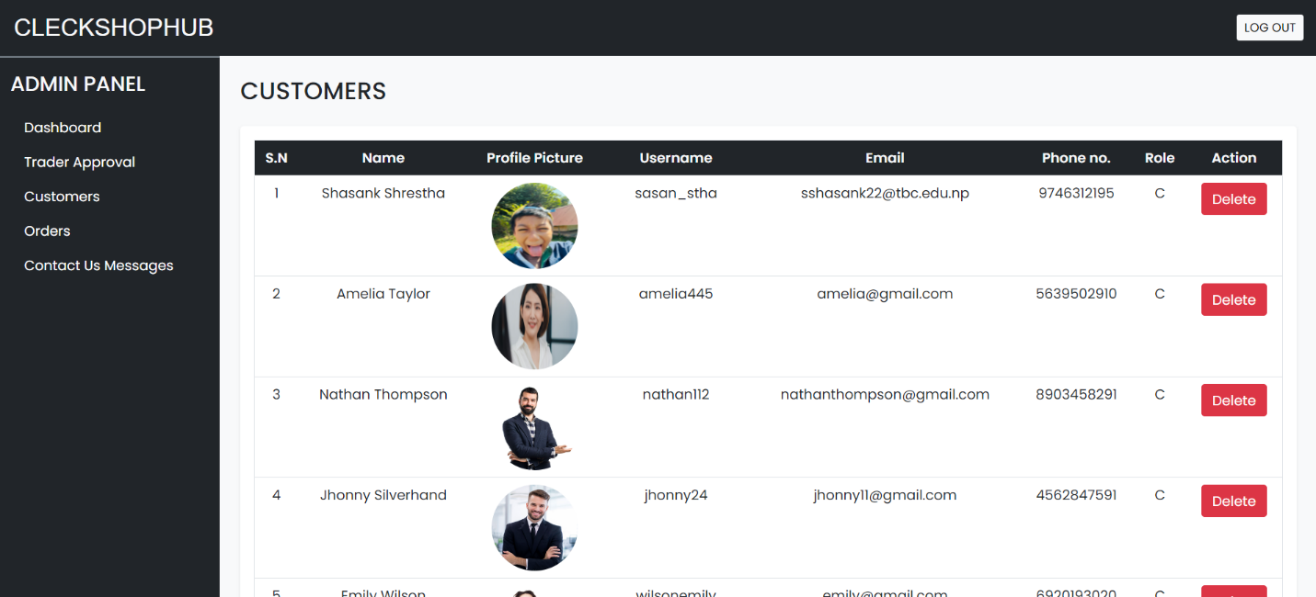

1. You can view all the messages and queries the customers have sent from the contact us form after clicking on Customer Message tab.

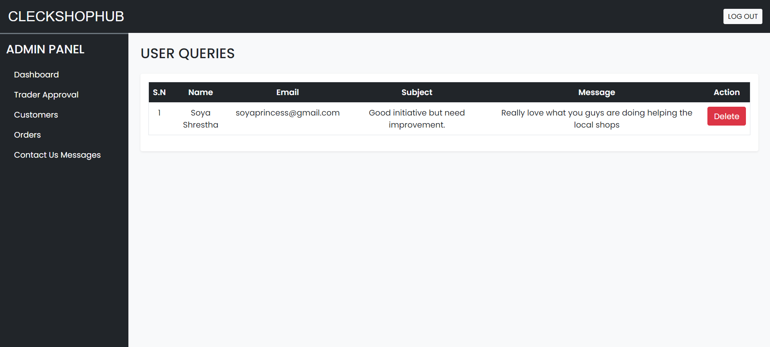

1. If you want to view reports of all the traders then you need to click on Report button on the top right of your Dashboard. After clicking on it will redirect you to Oracle Dashboard from where you can login with your username and password in lowercase.

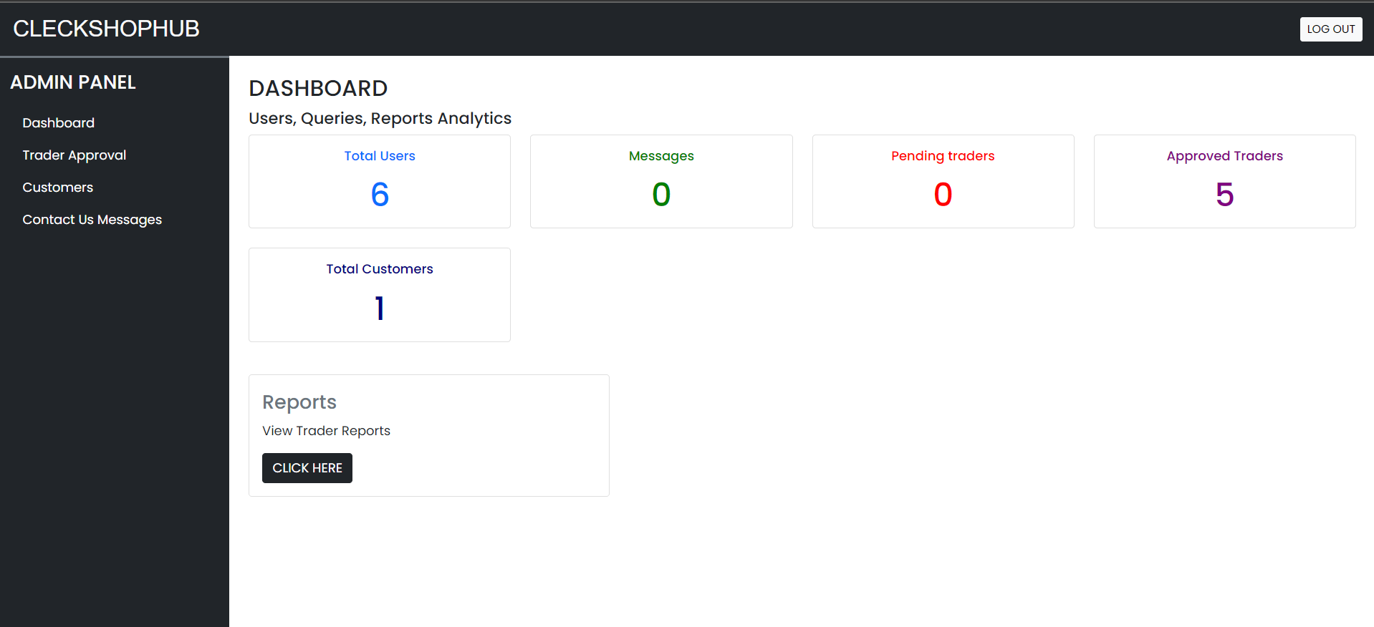

1. You can logout by clicking on Log out button on top right and then it will redirect you to homepage